Module 7 Executive Summary

Marcus Lee

CSE 450

12/13/2023

**1: Data Preprocessing.**

**Pre-processing Images: Implementing Data Augmentation**

**Objective of Data Augmentation:** To generate variations in images, thereby enhancing the model's ability to learn from diverse data and improving its predictive accuracy.

**Demonstration of Data Augmentation:** Displaying examples of augmented images with modifications in rotation, shift, zoom, and flipping.

**Construction of Data Generators:** Creation of data generators for the training and validation datasets, incorporating various data augmentation techniques.

The result is a new set of images with modifications from the original one, that allows to the model to learn from these variations in order to take this kind of images during the learning process and predict better never seen images.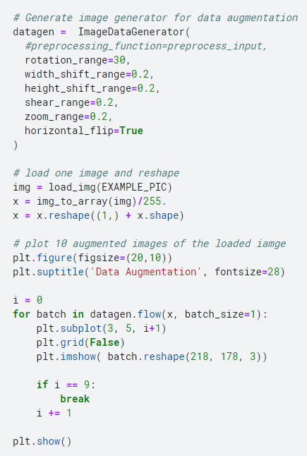

**2: Selection, Training, and Use of a Machine Learning Model.**

**2.1 Setting Up the Model**

**Using InceptionV3**: We start with a pre-trained model called InceptionV3, known for its efficiency in image recognition. It's adjusted to fit our image sizes but without its top layers, as we will add our own for gender recognition.

**Adding Custom Layers**: On top of InceptionV3, we add new layers to make the model suitable for our task:

* A layer to simplify the output of InceptionV3.
* Two layers to process the data further (with 1024 and 512 'neurons').
* A layer to reduce overfitting (where the model gets too fixated on the training data).
* Finally, a layer to classify the image into two categories: male or female.

**Final Touches**: We make sure the original InceptionV3 layers don't change during training. Then, we set up the model with specific settings for learning rate and loss measurement.

**2.2 Training the Model**

**How We Train**: We use the training data in a way that the model gradually learns from it, checking its performance on separate validation data. We save the best version of the model during this process.

**Results of Training**: After several cycles of learning (epochs), our best model successfully identifies gender in the validation data with about 95.75% accuracy.

**Visual Assessment**: We plot graphs showing how the model's accuracy and error changed over time during training. This helps us see how well the model learned.

**2.3 Evaluating the Model**

**Testing the Model**: We use the best version of our model and test it on new data it hasn't seen before.

**Performance on Test Data**: The model is able to correctly identify gender with about 92.6% accuracy on this new data, which is a strong result.

**Accuracy Metric**: We also calculate the F1 score, a statistic that tells us how precise and reliable the model's predictions are.

**Conclusion:**

In this project, we successfully adapted a powerful pre-trained image recognition model (InceptionV3) for the specific task of gender recognition. By training and testing it on a large dataset, we achieved high accuracy, demonstrating the effectiveness of our approach and the model's ability to generalize its learning to new, unseen images.

**3: Communication of Results**

**Simplifying Technical Jargon**: Use layman's terms to explain concepts like model training, accuracy, and data augmentation.

**Visual Representations**: Graphs and charts (like the training and validation accuracy and loss curves) can visually convey the model's performance over time.

**Contextualizing Results:** Relate the model's performance to real-world implications and potential applications.

**Addressing Limitations and Biases:** Be transparent about the model's limitations and any potential biases in the data or the model's predictions.

**Practical Implications**: Discuss how the model can be used in real-life scenarios, considering both benefits and risks.

**4: Communication of Results**

Interpreting the results of a machine learning model, especially in a gender recognition task using a model like InceptionV3, involves understanding what the model's performance metrics tell us about its effectiveness and potential limitations. Key points to consider include:

**Accuracy:** A high accuracy (92.6% on test data) suggests that the model is generally effective in distinguishing between male and female genders in images. However, it's important to remember that accuracy doesn't tell the whole story; it merely indicates the proportion of total correct predictions.

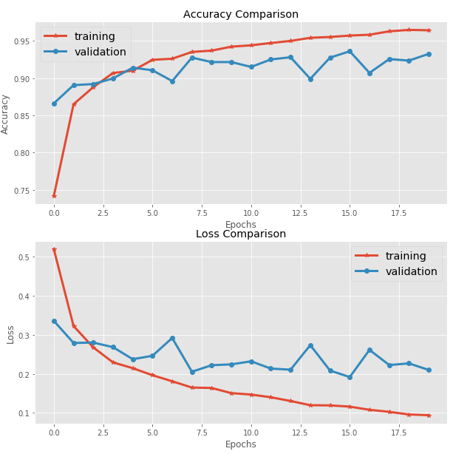

**F1 Score (0.9209):** This specific score is crucial. An F1 score near 0.92 suggests a strong balance between precision and recall. It indicates that the model not only accurately identifies gender in most cases but also maintains a balanced approach, reducing the likelihood of bias towards one gender.

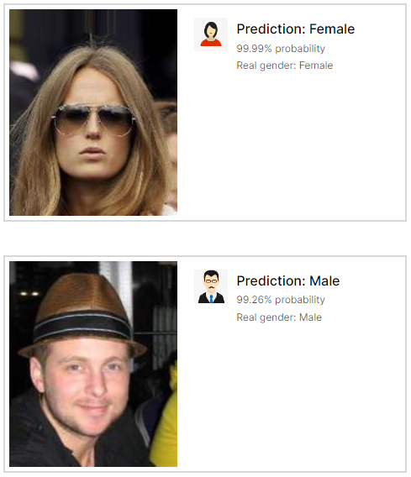

**5: Ethical Implementations**

The ethical considerations in machine learning, particularly in gender recognition models, are complex and critical:

**Bias and Fairness**: Ensure that the model does not perpetuate or amplify societal biases. This involves considering the diversity of the dataset and the potential for misclassification, especially in non-binary gender contexts.

**Privacy Concerns**: Respect the privacy of individuals whose images were used in the training and testing of the model. Ensure that data usage complies with privacy laws and ethical guidelines.

**Consent and Transparency**: Be transparent about how the model works and its intended use. Where applicable, ensure that consent was obtained for the use of personal data.

**Responsible Use:** Consider the potential applications of the model and avoid uses that could be harmful or discriminatory. This includes being wary of deploying the model in sensitive areas where misclassification could have serious consequences.

**Continuous Monitoring**: Regularly review and update the model to ensure it remains fair and accurate as societal norms and demographics evolve.

In summary, interpreting results involves a deep understanding of the model's performance and limitations; communicating results requires clear, accessible language and contextualization; and ethical implementation demands careful consideration of bias, privacy, consent, responsible use, and ongoing monitoring.